## KUBARSHI ACIKIN ZUNGERONSA

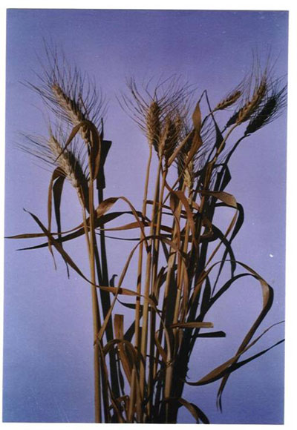

Allah (s.w) na cewa : " Yusuf ya kai mai gaskiya bamu fatawar shanu bakwai mai qiba suna cin bakwai busassu,  da zangeru bakwai koraye  da wasu busassu , ko zan koma ga mutane ko zasu sani* yace zaku yi noma shekaru bakwai a jere duk abin da kuka girba ku bar shi acikin zungeransa sai kaxan daga wanda zaku ci* Sannan wasu shekaru bakwai na fari zasu zo, sun cinye abin da kuka gabatar masu sai kaxan daga cikin waxanda kuka killace* sannan wani shekara zai zo mutane za su nemi gudunmuwa aciki zasu yi lallage) (yusuf 45-49)  Haqiqar Ilimi:  
Killace kwaya acikin zungeronsa wata babbar hanya ce na kiyaye amfanin gona  alokacin wahala.wannan shi ne ya haxe abinda ya shafi noma da ajiya da kiyaye abin da aka samu. Dokta Abdulmajid Bala'bid  da abokansa na jami'ar Ribat a Maroco sun gabatar da wani nazari akan  alkama da aka barta acikin zungeronta na tsawon shekaru biyu, da kuma wata alkamar da aka bar tsabarta , sakamakon binciken ya tabbatar da cewa wanda aka bari acikin zungeronta babu wani sauya da tayi baki xaya awurin lafiyarta 100%, ahannu xaya wanda aka cireta daga zungeronta ta rasa wasu abubuwa masu muhimmanci ajikinta, daga ciki hadda ruwan da yake ciki wato ta rasa nauyi 20,3% na nauyinta na  asali. Kamar yadda aka qara yin gwajin nomawa aka samu cewa na cikin zungeron yafi wancan kyau da tsawo da saurin tsirowa da girma.da kusa 20%  
Sannan wasu masu bincike suka qara samun cewa awurin kayayyakin gina jiki wancan mai zungeron yafi xayan amfani da kashi 23% acikin shekara biyu, da kuma 20% acikin shekara guda .  
Fuskacin Mu'ujizar:  
Allah (S.W) na cewa" abin da kuka girba ku bar shi acikin zungeransa" don yayi nuni da cewa barin hatsi acikin zungeronsa yafi amfani awurin ajiya, saboda baya saurin juyawa da juyin zamani anan akwai abubuwa biyu:  
iyakance lokacin amfanin noman da shekaru sha biyar  wato bakwai na nowa da girbi, bakwai na fari da qamfa sannan shekara xaya na buqatuwar mutane, suna lallagen 'ya'yan itatuwa . to bincike ya tabbatar da cewa shekaru sha biyar xin nan sune na iya amfani da kayan da aka ajiye, har asami amfaninsa.  
Hanyar kiyayewar ita ce "ku bar shi acikin zungeronsa" kuma wannan hanya ce ta ilimi da ya tabbatar wanda kuma ake aiki dashi a hanyoyin ilimi na zamani anan zamu cewa mafi nagartar hanya na kiyaye amfani itace wanda Annabi Yusuf ya bayyana. Kuma hatta misirawa na da basu san wannan hanyar ba waxanda suka zamo suna ajiyar tsaba ne kawai .kuma ambaton da al'qur'ani yayi ma wannan hanya ya nuna girman sa kenan kuma wahayi ne na ubangiji.